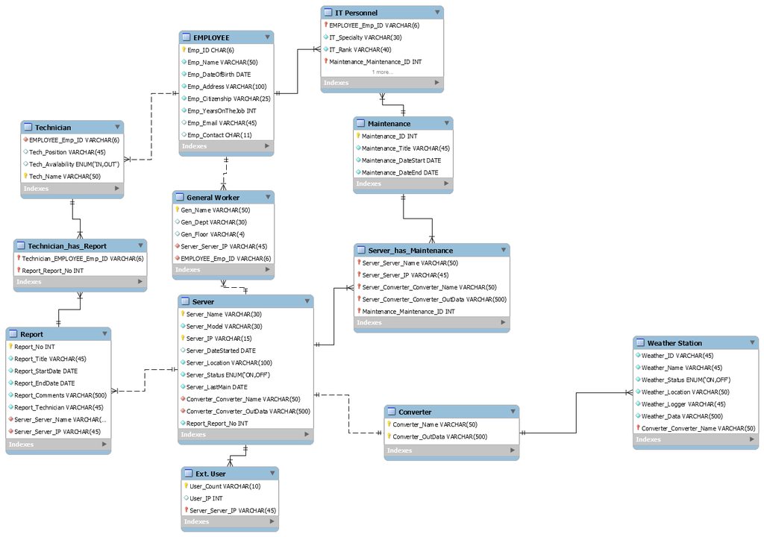

1..*

1..*

1..*

1..*

REPORT

ReportNo.

ReportTitle

ReportStartDate

ReportEndDate

ReportComments

ReportsTechnician

SERVER

S_Name

S_Model

S_IP

S_DateStarted

S_Location

S_Status

S_LastMaintenance

EMPLOYEE

EmpID

EmpName

EmpDateOfBirth

EmpAddress

EmpCitizenship

EmpYearsOnTheJob

EmpEmail

EmpContact

TECHNICIAN

TechName

TechPosition

TechAvailability

MAINTENANCE

MaintenanceID

MaintenanceTitle

MaintenanceDateStartMaintenanceDateEnd

WEATHER STATION

WeatherID

WeatherName

WeatherStatus

WeatherLocation

WeatherLogger

WeatherData

Conducts

holds



Writes

Assumes role



Is done to

1

1..*

1..*

1..*

1..*

1..*